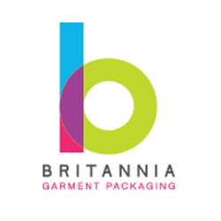
Company name:
Delivery postcode only & telephone:
Order quantity (moq 1000pcs):
Pantone colour(s):
Background colour:
Text Colour:
Which option(s) would you like a quote for? Please include the total size of the labels below:
*please note with GOTs certified organic cotton labels they can only be produced dyed white using organic ink or natural and for this material we strongly advise against block prints and badge labels*
Woven label | GOTS certified organic cotton in natural or dyed white please specify | Polyester satin label
Size: | Size: | Size:

Fold options please tick (please ensure you are okay with us adding the following sew space to the artwork as these are our minimum requirements when producing the folded labels).
8mm sew space | 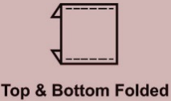  8mm top and bottom sew space | 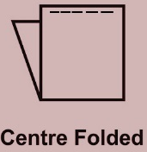  10mm top and bottom sew space | 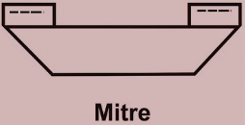  7mm sew space | 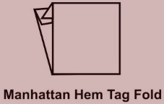  12mm top and bottom sew space

Do you also require size tabs? Please include all variants below:
_________________________________________________________________________________

Terms & conditions
Lead times start from the receipt of payment and production artwork approval. Please contact us if you are unsure of lead times prior to filling in this form. If you have ordered a pre-production sample there is a charge and it’s your responsibility to ensure all detailing/threading/sizing is as to your requirements.
Production artwork will not be shared until payment has been received. We can only allow one once the production artwork is shared.

