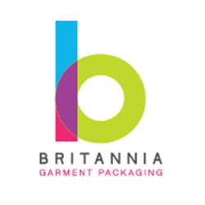
Company name:___________________________________________________________________
Delivery postcode only & telephone: ________________________________________________________________________________
Order quantity (moq 1000pcs):_________________________________________________________________________
Pantone colour(s)__________________________________________________________________
Background colour: _________________________________________________________________
Text Colour _______________________________________________________________________
Which option(s) would you like a quote for? Please include the total size of the labels below
Woven label | GOTs certified organic cotton in natural or dyed white please specify | Polyester satin label
Size: | Size: | Size:

Fold options please tick:
 | 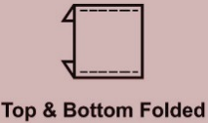 | 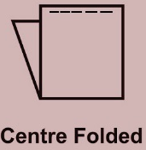 | 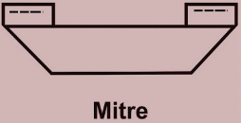 | 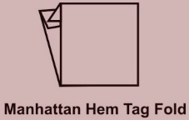

Do you also require size tabs? Please include all variants below:
_________________________________________________________________________________
Britannia quote & sizing advice

Terms & conditions
Lead times start from the receipt of payment and production artwork approval. Please contact us if you are unsure of lead time’s prior filling in this form. If you have ordered a pre-production sample there is a charge and it’s your responsibility to ensure all detailing/threading/sizing is as to your requirements.

